Decision Support Systems & Data Mining

How are Decision Support Systems and Data Mining Different?

- Decision Support Systems:

Provide the decision maker with an explicit mathematical formula that can be used to build various decision scenarios
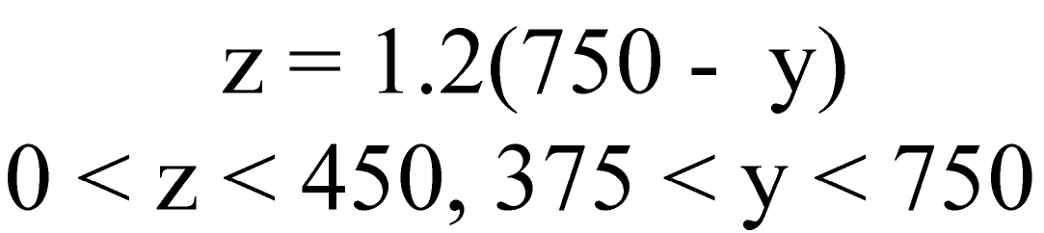

- Data Mining:

Provides the decision maker with information about interesting relationships among variables that suggest certain decision scenarios

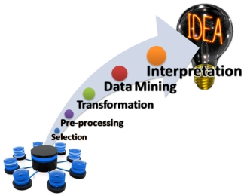

How are Decision Support Systems and Data Mining Similar?

They are both based on relational, rather than factual, information.

What is Relational Information, and where does it come from?

Factual Data Factual Information Relational Information

Fuel Purchase Data:
Fuel Purchase Information: MPG

- date
- mileage
- #gallons
Proper tire pressure improves fuel efficiency

Tire Pressure Adjustment data:
- date

is related to
Tire Pressure Fuel efficiency Model
(PSI) (MPG)

MPG = f (PSI)

Mathematical Model
not directly directly
controllable controllable

Why Build Models?
To control those things that cannot be controlled directly
via
controlling those things that CAN be controlled directly

Factual Information: What happens
Relational Information: How factors underlying what happens are related

The Anatomy of Mathematical Models

Mathematical Model

Y = aX₁ + bX₂ + c + d

Y = Dependent/Outcome Variable
That which we want to control/predict, but cannot do so directly
It is the outcome/consequence of other factors that we can control directly

X₁ , X₂ = Independent/Decision/Controllable Variables
Those factors that we can control directly, and whose correct values are in doubt (hence the need for a DSS)

a, b, c, d = Decision Parameters, Uncontrollable Variables, Environmental Factors
Those factors that affect the Dependent/Outcome Variable but cannot be controlled by the decision maker; their values are “given” in a particular situation.

The Central Challenge of DSS:
- Given certain values of a/b/c/d, what values of X₁/X₂ will produce the desired value of Y?

DSS ≠ DAS

DSS = Decision Support Systems
A system that supports/aids the decision maker; the decision is made by the decision maker
semi-structured decision situations

DAS = Decision Automation System
A system that replaces the decision maker; the decision is delegated to the computer
Fully-structured decision situations

For a brief but useful textbook coverage of DSS, read An Introduction to DSS
http://zimmer.csufresno.edu/~sasanr/Teaching-Material/MIS/DSS/DSS-Intro.pdf

The role of Intermediate Variables in facilitating the derivation of the model:

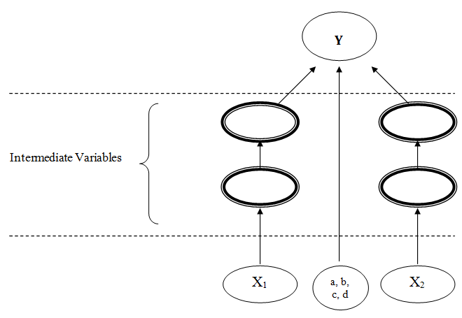

Using Mathematical Models

- What-if Analysis:
Given certain (hypothetical) values of the independent variables, what is the corresponding value of the dependent variable?

Y = ?
X₁ = m
X₂ = n

- Goal-seek Analysis:
Given a certain desired value of the dependent variable, what values of the independent variables would produce it?

Y = k
X₁ = ?
X₂ = ?

- Sensitivity Analysis:
How sensitive is the dependent variable to changes in a certain independent variable when everything else is kept constant?

X₁ = X₂ = n
- m1
- m2
- m3
- m4
Y =
- ?
- ?
- ?
- ?

- Optimization Analysis:
When the independent variable should not be maximized or minimized because it involves a tradeoff, which value of it will optimize the independent variable?

A Case Study in Sensitivity Analysis

Question:

Which student’s Course Grade is more sensitive to their Term Paper Grade?

Which student’s term paper should the professor read more carefully?

Background:

Both students S1 and S2 have met all the course requirements except the term paper (worth 10%)

Student | Total Score So Far  (Max = 90%) | Term Paper Grade  (Max=10%) | Course Grade  (Max = 100%)
S1 | 78% | - A (9-10)  - B (8-9)  - C (7-8)  - D (6-7)  - F (< 6)  - does not turn in
S2 | 82% | - A (9-10)  - B (8-9)  - C (7-8)  - D (6-7)  - F (< 6)  - does not turn in

Grading Scale:

F D C B A
_____________|_____________|_____________|_____________|_____________|
60 70 80 90 100


A Case Study in Optimization: T.A.C.O.

–

Profit
+

+ –

Revenue

Expense

–

Number of customers likely to balk
(acceptable level < 2.5%)

+

Payroll

–

Speed of Service
(acceptable level < 3 m)

+ +
Parameter:
Store activity level
(Forecasted)

Customer-service staffing level per shift (80% of labor requirements)

Duration/shift

Data Mining

Automated discovery of patterns in large transaction-based data sets and transforming them into an understandable structure for further use

Computer Models in Hollywood
http://zimmer.csufresno.edu/~sasanr/Teaching-Material/MIS/DSS/computer-models-in-hollywood.pdf

The System
Script Projected ROI

The Verdict:
Decision Process | ROI
Traditional approach | -24.4%
Random selection | -18.6%
DSS model | +5.1%

Mining Consumer Data in Politics
http://zimmer.csufresno.edu/~sasanr/Teaching-Material/MIS/DSS/mining-consumer-data-in-politics.pdf

The System
Life Style Variable Voting behavior

      - car
      - music
      - drink

Drug Industry Mines Physicians' Data to Boost Sales
Listen to it
Read it
http://zimmer.csufresno.edu/~sasanr/Teaching-Material/MIS/DSS/Drug%20Industry%20Mines%20Physicians.pdf

Pharmaceutical Company:

Promote Product

Doctor:

Write Prescription

Pharmacist:

Fill Prescription

prescription prescription
details data

